**ePerformance Reports and Queries**

There are two ePerformance forms that employees, managers and HR administrators can access through PeopleSoft ePerformance.

* Mid-Year Performance Review (for agencies using ePerformance for their mid-year review)
* Annual Performance Review

There are four ePerformance reports that HR administrators can access through PeopleSoft ePerformance to provide them with additional information on ePerformance implementation within their agency.

* Missing Documents Report
* Late Documents Report
* ePerformance Manager Override Report
* HR Admin Doc Status Report

There are nine queries that HR administrators can run from PeopleSoft ePerformance to extract data about their agency’s use of the ePerformance tool.

* 0EP001_DEPT_CNT - ePerformance Document Count by Department
* 0EP002_BY_COUNT_CRIT_NOT_ESTAB - By Count - Criteria Not Established
* 0EP003_EMPL_CRIT_NOT_ESTABLISH - By Employee - Criteria Not Established
* 0EP005_RUNCTL_GRP_VALIDATE - Validate Group and Runcontrol
* 0EP007_NOT_IN_MGR_LST – HR Admin Not in Manager List
* 0EP008_NOT_IN_MGR_MGR_LST – HR Admin Not in Manager’s Manager List
* 0EP009_EP_DOC_PROCESS_STATUS – ePerformance Document Process Status
* 0EP010_DOC_SLFEVAL_STATUS – ePerformance Document Status with Self-Evaluation Status
* 0EP011_Rev_Man_Apprv – Reviewing Manager Approval Status

|  |  |
| --- | --- |
| **Report Name:** ePerformance Mid-Year Performance Review  **Purpose:** Completed at mid-year, this document provides an opportunity for discussion between the employee and the manager as to how well the performance expectations developed at the beginning of the fiscal year are being met.  On the mid-year review document, managers rate their employees on each competency, individual goal, and/or job responsibility assigned. Comments are included at the end of each section to allow managers to provide feedback to support the ratings given.  **How Accessed:** The manager, employee and HR administrator can print the mid-year evaluation from ePerformance. |  |

|  |  |
| --- | --- |
| **Report Name:** ePerformance Year-End Performance Review  **Purpose:** Completed at the end of the performance cycle, this document provides an opportunity for discussion between the employee and the manager as to how well the performance expectations developed at the beginning of the fiscal year were met over the course of the year.  On the Year-End review document, employees have the opportunity to complete a self-evaluation to ensure that their manager has a comprehensive picture of the employee’s work and how the work has added value and impacted the business  After the self-evaluation, managers rate their employees on each competency, individual goal, and/or job responsibility assigned. Comments are included at the end of each section to allow managers to provide feedback to support the ratings given.  **How Accessed:** The manager, employee and HR administrator can print the year-end evaluation from ePerformance. |  |

HR administrators have the ability to run specific reports from PeopleSoft ePerformance to extract data about their agencies use of the ePerformance tool. Below is an outline of four reports that are available to the HR Admins.

|  |  |
| --- | --- |
| **Report Name**: Missing Documents Report  **Purpose:** HR Administrators use this report to identify individuals who do not have performance documents.  HR Administrators can also use this report to ensure that everyone in a specific group currently has a document based on the criteria entered.  In addition, HR Administrators can generate a list of missing performance documents for a group of employees and for a given document type and date range.  Key fields include employee name and ID, agency, business unit, and dept number and description, job code, salary plan and grade.  **How Accessed:** HR administrator can access this report through PeopleSoft by selecting Workforce Development, Performance Management, Reports. |  |

|  |  |
| --- | --- |
| **Report Name**: Late Documents Report  **Purpose:** This report allows HR Administrators to generate a list of late performance documents by document type for a group of employees.  To determine whether a report is late, the system compares the document due date with the current date. If the current date is greater than the due date and the document status is not yet Complete, then the system reports the document as late. The report ignores canceled performance documents.  Key fields include employee name and ID, dept number and description, manager name and ID, document status and due date.  **How Accessed:** HR administrator can access this report through PeopleSoft by selecting Workforce Development, Performance Management, Reports. |  |

|  |  |
| --- | --- |
| **Report Name**: Manager Override Report  **Purpose:** This report allows HR Administrators to identify the managers within their agency who used the override function to complete the evaluation process. The override function is used if an employee refuses to acknowledge that the review was held or if the employee is not able to log into the system to acknowledge the review was held.  Key fields include manager name and ID, employee name and ID, reason and overall rating.  **How Accessed:** HR administrator can access this report through PeopleSoft by selecting Workforce Development, Performance Management, Reports. |  |

|  |  |
| --- | --- |
| **Report Name**: HR Admin Doc Status Report  **Purpose:** This report allows HR Administrators rep to search for documents that are awaiting approval.  Key summary fields include agency name, review period, and department name.  Key detail fields include employee name, review type, title, review rating, manager name, approval status, and document status.  **How Accessed:** HR administrator can access this report through PeopleSoft by selecting Workforce Development, Performance Management, Reports. | Summary Information    Detailed Information |

HR administrators have the ability to run queries from PeopleSoft ePerformance to extract data about their agencies use of the ePerformance tool. Below is an outline of the public queries that have been made available to the HR community.

To access the ePerformance queries, go to the Route 88 Query URL, <https://route88qry.state.ga.us/>, to access the PeopleSoft query functionality. The ePerformance queries are located under the Reporting Tools option available on the left nav bar.

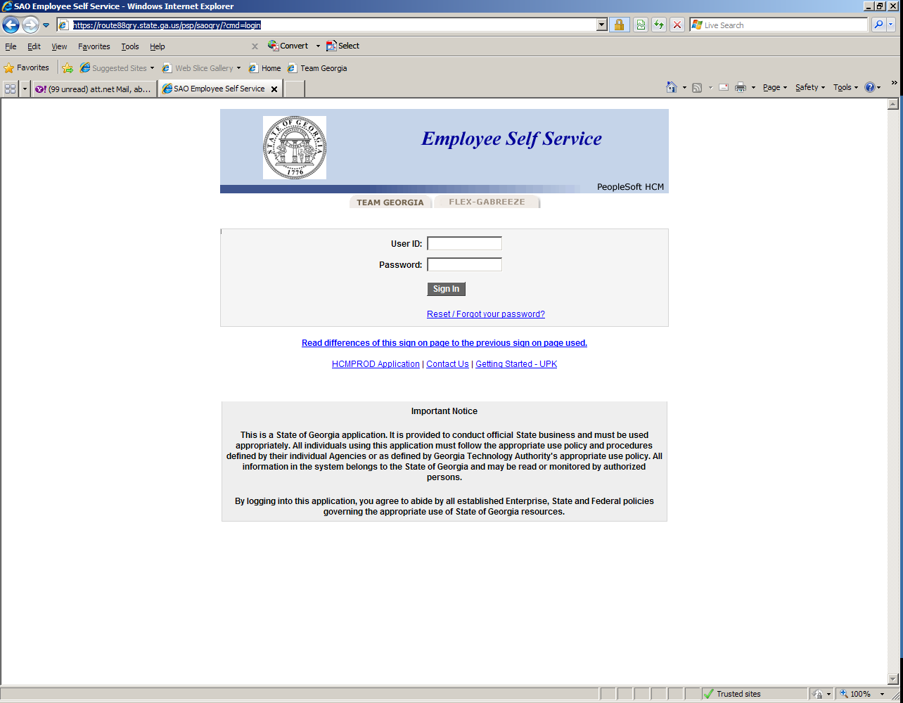 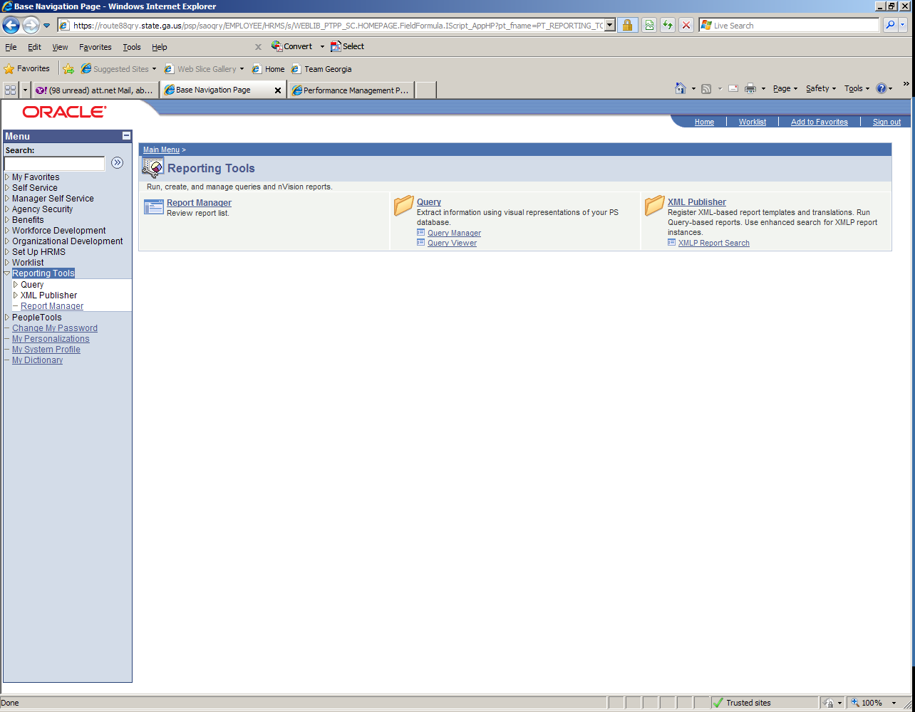

|  |  |
| --- | --- |
| **Query Name**: 0EP001_DEPT_CNT - ePerformance Document Count by Department  **Purpose:** Displays the number of documents created within an agency by department. Includes summary information on ratings.  Users will be prompted to enter their agency number, the type of document being queried (annual vs. mid-year) and the period begin and end dates.  Key fields include Agency name, department name, document type, period begin and end dates, total number of documents created, and then a breakdown documents created by rating number. Includes numbers not yet rated.  **How Accessed:** HR administrators can run ePerformance queries by logging into PeopleSoft using the ESS/Teamworks login page, selecting Administrative Systems, then HCM Query Manager. |  |

|  |  |
| --- | --- |
| **Query Name**: 0EP002_BY_COUNT_CRIT_NOT_ESTAB - By Count Criteria Not Estab  **Purpose:** Displays the number of performance documents that have not been started by manager name. Can be used by HR administrators to identify which managers to follow up with regarding the creation of performance plans.  Users will be prompted to enter their agency number, the type of document being queried (annual vs. mid-year) and the period begin and end dates.  Key fields include agency name, document type, period begin and end dates, manager name and employee number, and the total number of documents not established for each manager.  **How Accessed:** HR administrators can run ePerformance queries by logging into PeopleSoft using the ESS/Teamworks login page, selecting Administrative Systems, then HCM Query Manager. |  |

|  |  |
| --- | --- |
| **Query Name**:  0EP003_EMPL_CRIT_NOT_ESTABLISH - By Employee Criteria Not Established  **Purpose:** Displays the number of performance documents that have not been started by employee name. Can be used by HR administrators to identify which specific employees do not have performance plans completed for them.  Users will be prompted to enter their agency number, the type of document being queried (annual vs. mid-year) and the period begin and end dates.  Key fields include agency name, document type, period begin and end dates, manager name and employee number, and employee names and numbers of those who do not have performance plans established.  **How Accessed:** HR administrators can run ePerformance queries by logging into PeopleSoft using the ESS/Teamworks login page, selecting Administrative Systems, then HCM Query Manager. |  |

|  |  |
| --- | --- |
| **Query Name**:  0EP005_RUNCTL_GRP_VALIDATE - Validate Group and Run Control  **Purpose:** Identifies who created documents and run control ID used. Can be used by HR administrators to determine the run control ID used to create the document.  Users will be prompted to enter their agency number, the group ID and the template ID.  Key fields include operator ID, run control, employee record, name and ID, job effective date, department name and ID, manager ID, document ID, template ID, period begin and end dates, creation date and time, who created it, and the status.  **How Accessed:** HR administrators can run ePerformance queries by logging into PeopleSoft using the ESS/Teamworks login page, selecting Administrative Systems, then HCM Query Manager. |  |

|  |  |
| --- | --- |
| **Query Name**:  0EP007_NOT_IN_MGR_LST – HR Admin Not in Manager List  **Purpose:** Displays documents that are not currently displaying in the Managers’ queue. This provides detailed information for better problem solving with the Performance Management Help Desk and SAO.  Users will be prompted to enter their agency number, the type of document being queried (annual vs. mid-year), the period begin and end dates, and the HR Administrator’s ID.  Key fields include company ID, agency department ID, employee record number, name and ID, process step, user ID, SS role type, role name, process action, SS Group ID, document ID and rating.  **How Accessed:** HR administrators can run ePerformance queries by logging into PeopleSoft using the ESS/Teamworks login page, selecting Administrative Systems, then HCM Query Manager. |  |

|  |  |
| --- | --- |
| **Query Name**: 0EP008_NOT_IN_MGR_MGR_LST – HR Admin Not in Mgr's Mgr List  **Purpose:** Displays documents that are not currently displaying in the Reviewing Managers’ queue. This provides detailed information for better problem solving with the Performance Management Help Desk and SAO.  Users will be prompted to enter their agency number, the type of document being queried (annual vs. mid-year), the period begin and end dates, and the HR Administrator’s ID.  Key fields include company number, department ID, employee name and ID, process step, user ID, SS role type, role name, process action, SS Group ID, document ID and rating.  **How Accessed:** HR administrators can run ePerformance queries by logging into PeopleSoft using the ESS/Teamworks login page, selecting Administrative Systems, then HCM Query Manager. |  |

|  |  |
| --- | --- |
| **Query Name**: 0EP009_EP_DOC_PROCESS_STATUS - ePerf_Doc_Process_Status  **Purpose:** Displays the status of all performance documents. Includes ratings if they’ve been assigned. Can be used by HR administrators to determine the status of performance evaluations or the ratings distribution within the agency.  Users will be prompted to enter their agency number, the type of document being queried (annual vs. mid-year) and the period begin and end dates.  Key fields include agency name and number, department name and number, date document created, document type, period begin and end dates, manager name and number, employee name, number, job code and title, document statuses and actual and rounded ratings.  **How Accessed:** HR administrators can run ePerformance queries by logging into PeopleSoft using the ESS/Teamworks login page, selecting Administrative Systems, then HCM Query Manager. |  |

|  |  |
| --- | --- |
| **Query Name**: 0EP010_DOC_SLFEVAL_STATUS  - ePerf Doc Stat / SelfEval Stat  **Purpose:** Displays the status of all performance documents. Includes ratings if they’ve been assigned. This query includes all the information is 0EP009, but also displays the status of the employee self-assessment and the employee acknowledgement. Can be used by HR administrators to determine the status of performance evaluations or the ratings distribution within the agency.  Users will be prompted to enter their agency number, the type of document being queried (annual vs. mid-year) and the period begin and end dates.  Key fields include agency name and number, department name and number, date document created, document type, period begin and end dates, manager name and number, employee name, number, job code and title, document statuses and actual and rounded ratings.  **How Accessed:** HR administrators can run ePerformance queries by logging into PeopleSoft using the ESS/Teamworks login page, selecting Administrative Systems, then HCM Query Manager. |  |

|  |  |
| --- | --- |
| **Query Name**:  0EP011_REV_MAN_APPRV  - ePerf Reviewing Manager Approval  **Purpose:** Displays the status of performance documents approved by the reviewing manager. This will allow the HR Administrators to determine if the Reviewing Manager has approved an employee’s performance document.  Users will be prompted to enter the employee ID, the type of document being queried (annual vs. mid-year) and the period end date.  No search results will display if the Reviewing Manager has not approved the document. If the document has been approved, the **Step Status** field will read **Approved**.  **How Accessed:** HR administrators can run ePerformance queries by logging into PeopleSoft using the ESS/Teamworks login page, selecting Administrative Systems, then HCM Query Manager. |  |